SeaTTle Spicy Wing Bites

Seattle Dogs

Denver Dogs

Seattle Dogs

Table Card Designs: © JamieO.co

Super Bowl PIZZA Pockets

Seattle Dogs

Quarterback PIZZA Pockets

Seattle Dogs

Table Card Designs: © JamieO.co

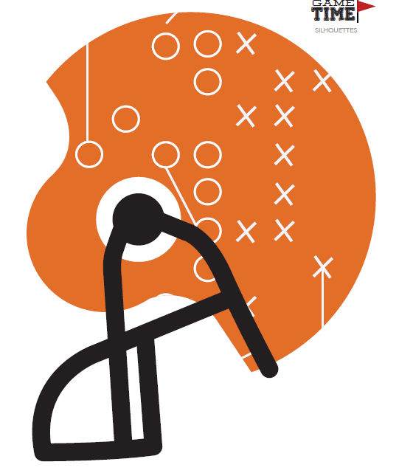

Photobooth Cutouts: Hostess with the Mostess®

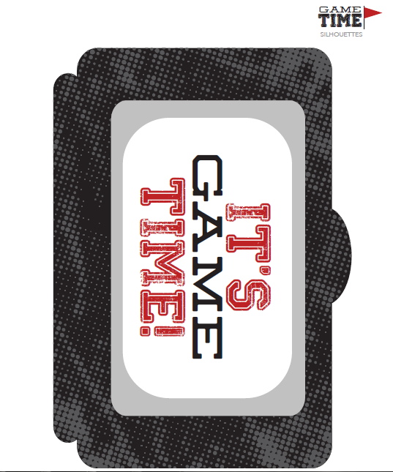
Photobooth Cutouts: Hostess with the Mostess®

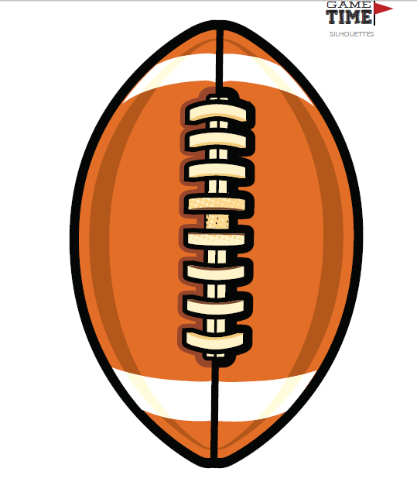
Photobooth Cutouts: Hostess with the Mostess®

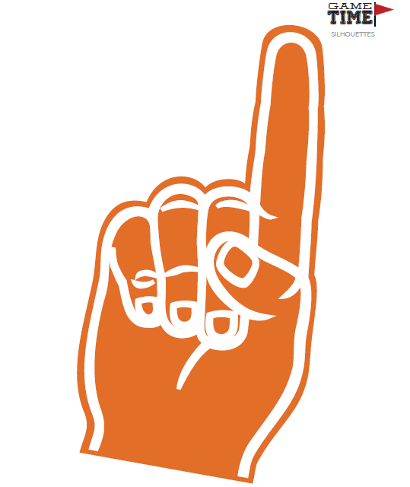
Photobooth Cutouts: Hostess with the Mostess®

