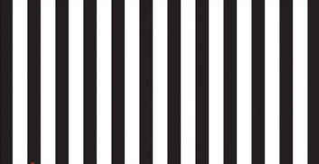

SeaTTle Spicy Wing Bites

Seattle Dogs



Denver Dogs

Seattle Dogs



Super Bowl PIZZA Pockets

Seattle Dogs



Quarterback PIZZA Pockets

Seattle Dogs